**Docker Configuration and basic commands**

1. Create a EC2 instance (Linux) in AWS

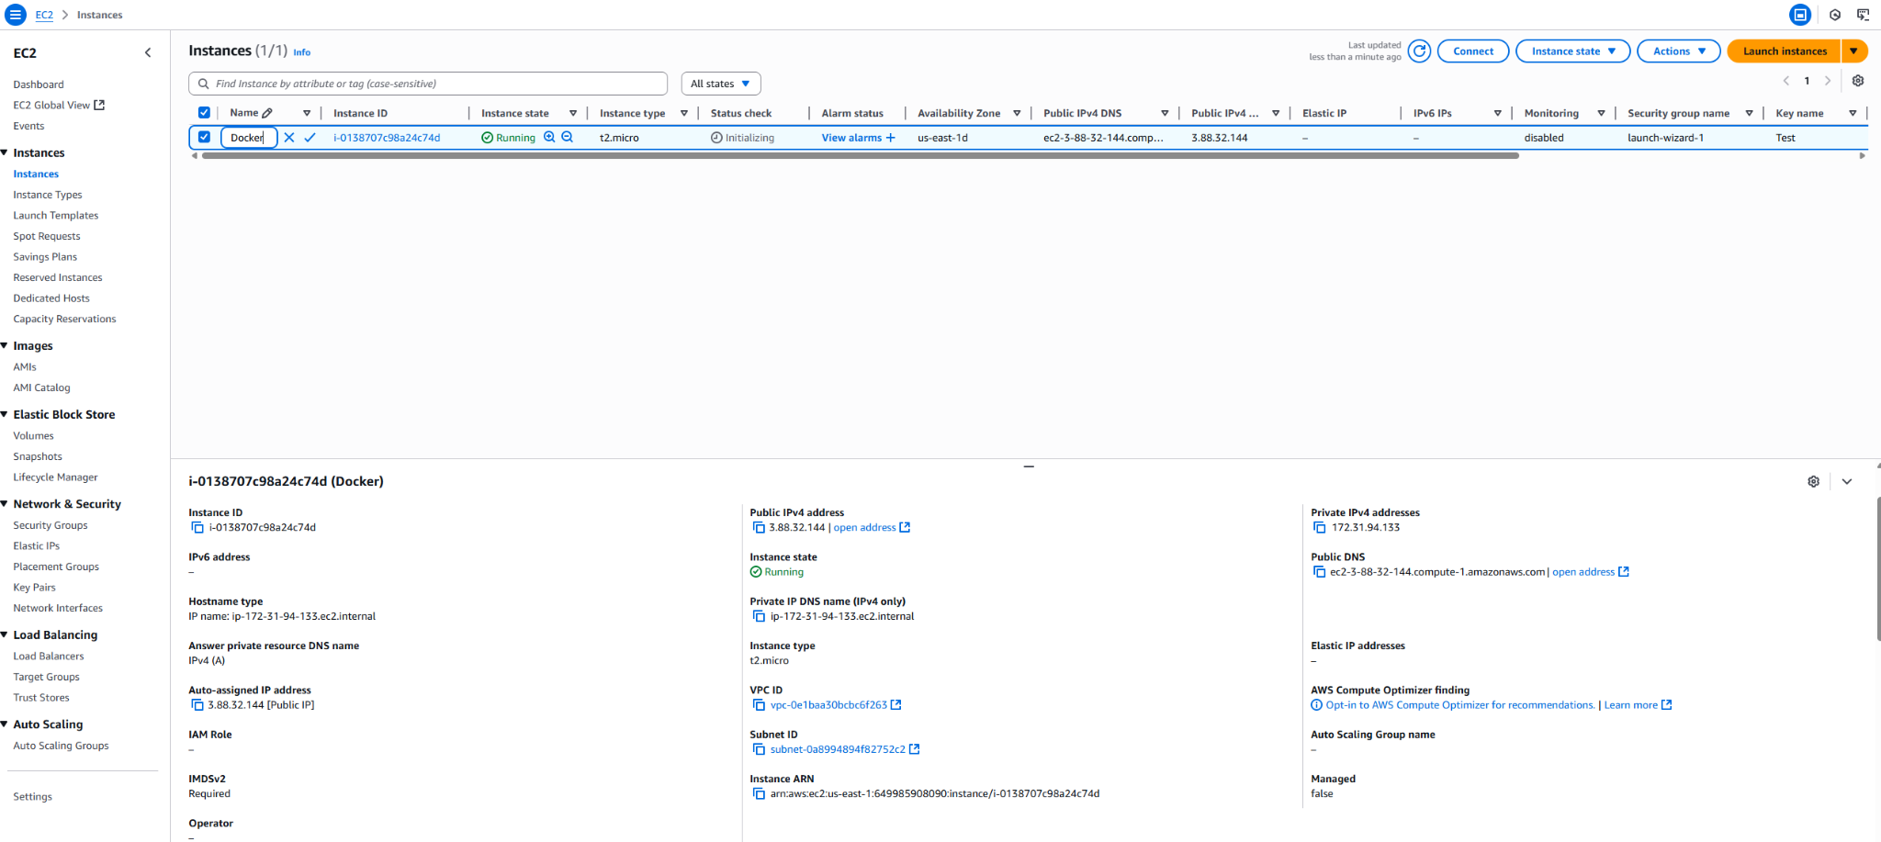

2. Install the docker on Linux instance

# Add Docker's official GPG key:

sudo apt-get update

sudo apt-get install ca-certificates curl

sudo install -m 0755 -d /etc/apt/keyrings

sudo curl -fsSL https://download.docker.com/linux/ubuntu/gpg -o /etc/apt/keyrings/docker.asc

sudo chmod a+r /etc/apt/keyrings/docker.asc

# Add the repository to Apt sources:

echo \

"deb [arch=$(dpkg --print-architecture) signed-by=/etc/apt/keyrings/docker.asc] https://download.docker.com/linux/ubuntu \

$(. /etc/os-release && echo "${UBUNTU_CODENAME:-$VERSION_CODENAME}") stable" | \

sudo tee /etc/apt/sources.list.d/docker.list > /dev/null

sudo apt-get update

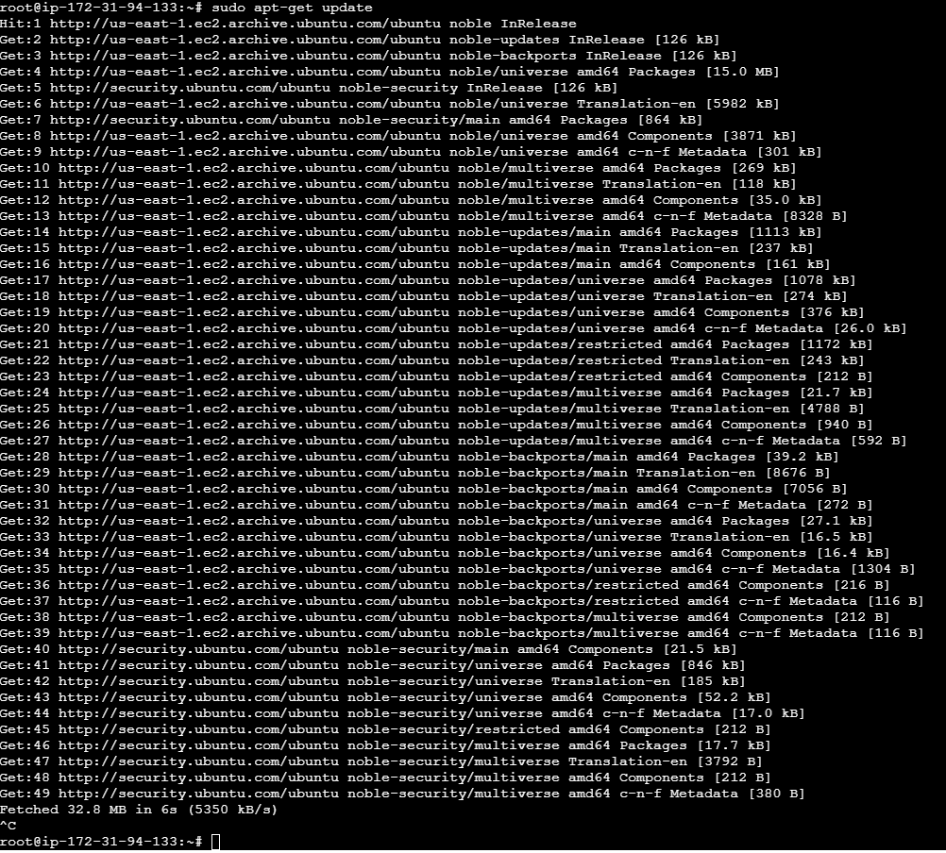

sudo apt-get install docker-ce docker-ce-cli containerd.io docker-buildx-plugin docker-compose-plugin

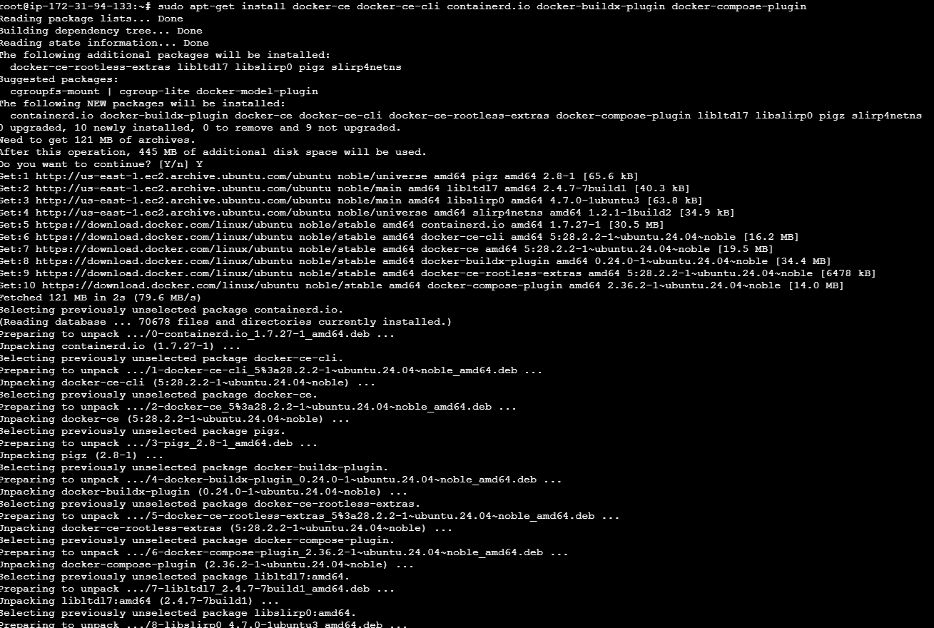

sudo docker run hello-world

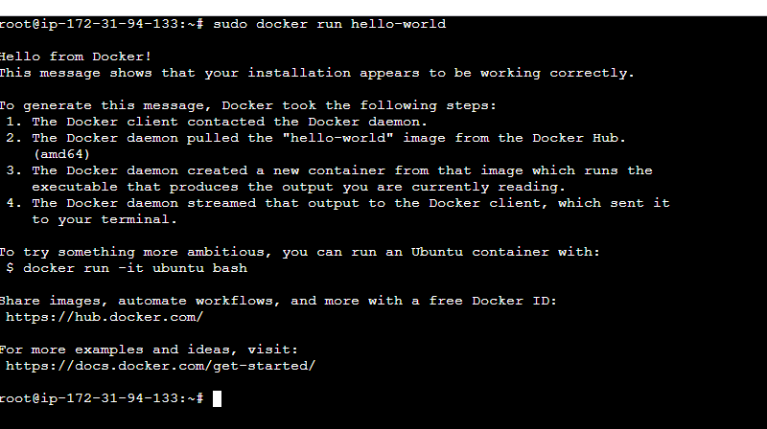

Basic commands

Docker ps : Containers List  


Docker ps -a : containers running + dead



docker ps -qa : only container ID is listed for the containers

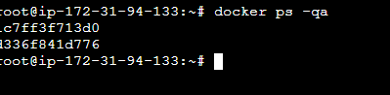

Docker top container ID : gets process ID of containers.

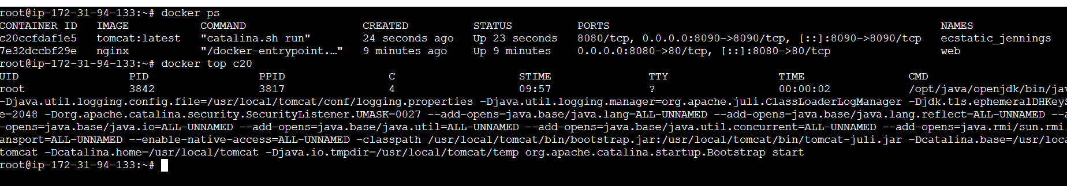

Install tomcat on the docker

docker run -d -p 8080:8080 tomcat:latest

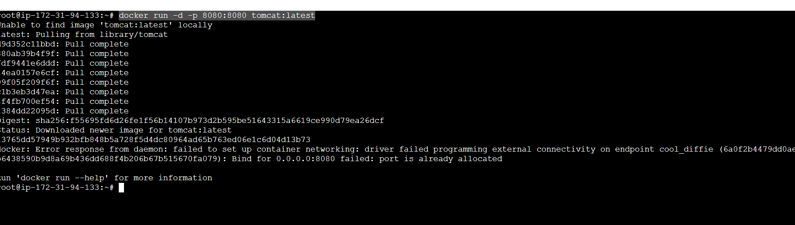

Nginx command:  
docker run -it --rm -d -p 8080:80 --name web nginx

DOCKER lifecyle

docker stop contID - to stop container

Docker start contID - to create

Docker run imageID - spin of with image ID

Docker rm contID - to remove

docker create : docker create + docker start = docker run - to create a container from img

Docker build dockerfile = docker image create

docker exec -it 7e bash : take access of the container



docker inspect contid : complete details on container

docker logs contid: running processes of the container